In Ms. Skufca’s Art Class students are working on an online drawing board to create designs that demonstrate understanding of Color Theory. Check out the link if you would like to try drawing on it: [**https://www.tutorialspoint.com/whiteboard.htm**](https://www.tutorialspoint.com/whiteboard.htm)

**Warm Color Geometric Design by Joshua Dannison Gr 6**

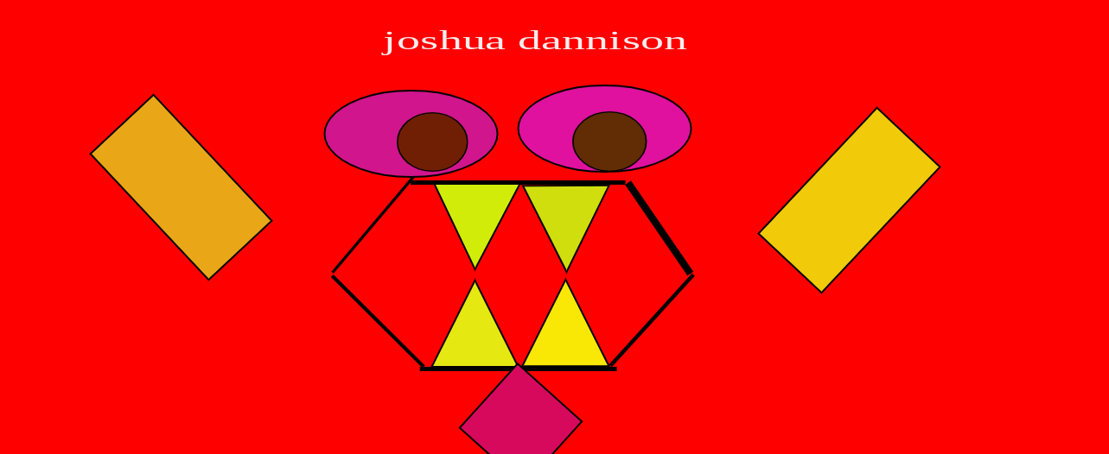

**Warm Color Geometric Design by Velontae Robinson Gr 7**

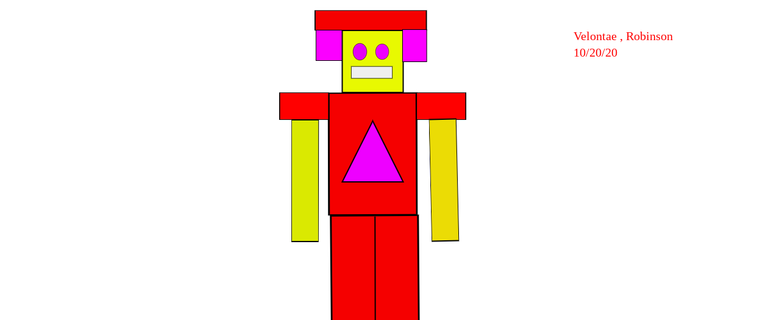

_____________________________________________________________________________________

**Shapes Drawing by Genevieve Simon Kindergarten**

